**IOT Smart Lighting System**

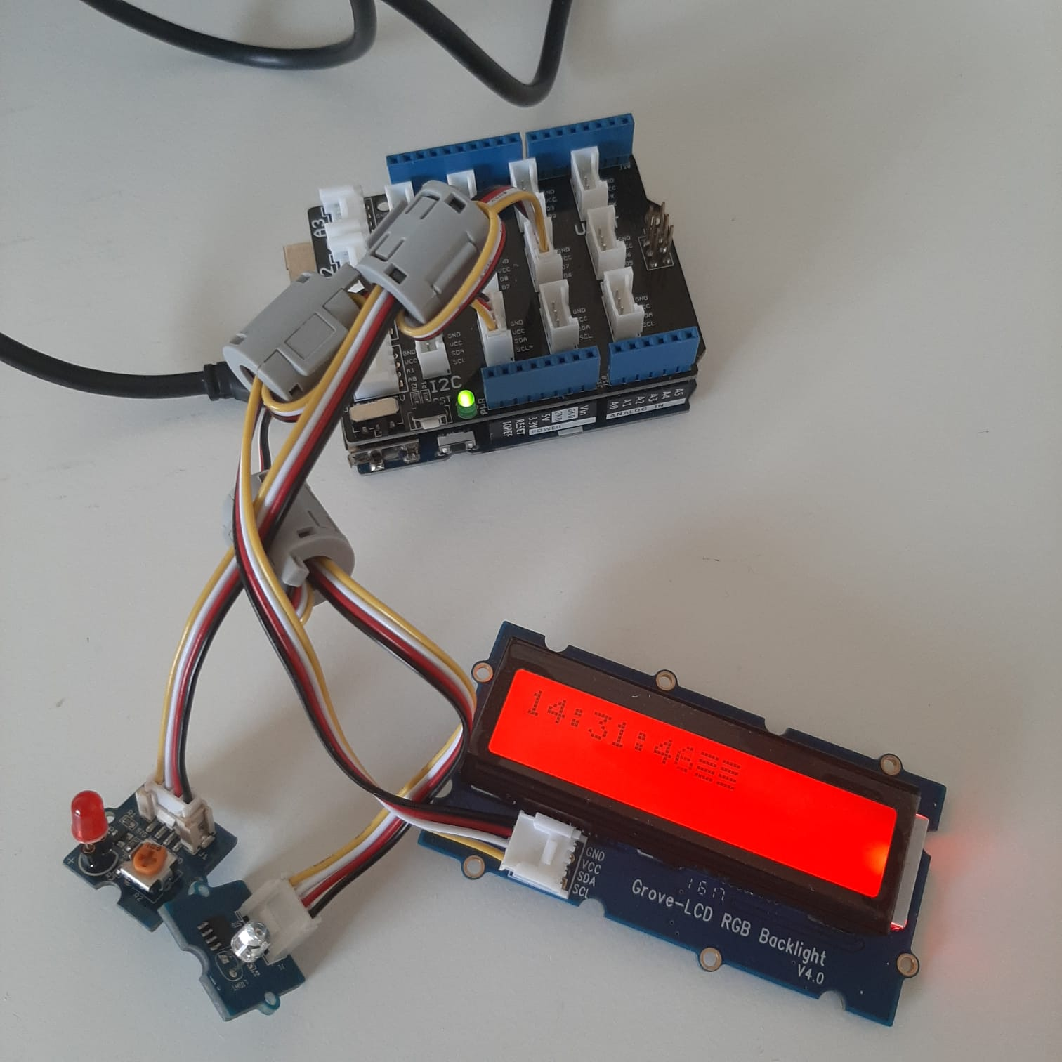

**Group Members:**

Paul Mulvaney (Mulvaney.Paul@mail.itsligo.ie) : Problem to be solved, Project Solution  
Martin Melody (Martin.Melody@mail.itsligo.ie) : Project Requirements, Initial Design  
Aaron Houston (Aaron.Houston@mail.itsligo.ie) : Implementation Plan  
Kieran Boyle (Kieran.Boyle@mail.itsligo.ie) : Testing; Security and future Improvements

**Links:**

Trello Page: : https://trello.com/b/3eBxkrN8/iot-board

GitHub Team Page: : https://github.com/AaronH18/IoTSmartLight

Presentation : https://mailitsligo-my.sharepoint.com/:p:/g/personal/s00211628_mail_itsligo_ie/EVegqB4ltBVAkh1q3tdNn9YBVNADSRFxwSHq79_Wd699Zw?e=bwdMPA

**Problem to be solved**

For this project the problem we are trying to solve is relatively simple. To help ease strain and improve productivity and mental health of computer users by keeping them in a well-lit, and productive environment through the use of a dynamic lighting system. Using a lighting system that will automatically adjust to the users’ needs by adjusting the colour temperature and brightness of the light in their office based on the time of day and the amount of natural light filtering into the workspace. By adjusting the brightness, we hope to keep the user’s workspace at a similar level of brightness throughout their day. While also using an internal clock, we hope to keep the colour temperature of this light at the optimal level depending on the time of day. Thereby negating some of the effects of blue light on the user’s eyes, sleep patterns and mental health.

For the past year due to Covid-19 many business, schools and colleges have pivoted to a work from home model. While some people’s workflow is entirely unimpeded, the reality for most is that they are now working in an area that was never intended to be used as a permanent office. This has led to a number of people working in workspaces that could be more damaging to themselves than they potentially realise. The cold blue light given off by computers, smartphones and other devices has been linked to a number of health issues.[1] And being unaware and not taking the correct precautions can worsen the situation for a user. What we aim to provide is a lighting system that can be used in a number of forms to provide the user a safer and more productive workplace.

Another area we hope to cover with this is the improvement of the users overall mental health. The blue light given off by computers has been known to directly affect the circadian rhythm of human beings. Prolonged blue light exposer can through off a natural sleeping pattern.[2] Using this kind of blue light until the end of a working day at around 6 o’clock can lead to the user staying up later, not getting the recommended amount of sleep and feeling more tired throughout the day. This can have a number of negative impacts. Most quickly a decrease in productivity but over time this sleep pattern change has been known to cause problems with mental health.[3] Our aim is to introduce a yellow light to the users work environment there by negating the damage done by blue light, we hope this will promote a better sleeping pattern for our user base and in turn potentially reduce mental health issues and also increase the users productivity throughout the day.

Lastly the simplest solution we aim to solve is light. It can be often overlooked the importance of good lighting in the workplace. While providing the user with a light system that adjusts to the ambient light levels of the workspace, we are hoping to keep them in a consistently lit working environment throughout the day.

**Summary of Project Solution**

Our end goal with this project is to create an automatically adjusting lighting system that will keep the user a recommended level of light throughout the day. Keeping the user in a well-lit environment is the simplest problem. Using a light sensor, we will be able to read in the value of light within the room. Using this value against a tested recommended level we will be able to raise or lower the brightness of the light as needed as the day goes on.   
The next part of the solution is the colour temperature. We are hoping to negate negative effects of blue light exposure on the use throughout the day. This will be achieved by adjusting the colour temperature of the as the day goes on progressively going from blue at the start of the workday to a more-soft yellow, orange tone. By reading from the user’s pcs internal clock we can thereby find the current time and adjust the colour temperature as needed.

**Rough illustration of proposed solution.**

Beginning with the light. As a realised project we would using colour changing and dimmable LEDs. This is preferred over a traditional light bulb as it offers the final products cheap build cost as well as cheaper running cost. These LEDs are also smaller and can made to fit into simple USB desk lights if the user does not have space for another light in their workspace. The solution for this is relatively simple, throughout the day using a light sensor we can take in a value, this representing the ambient level of light in the user’s workspace. Depending on this value we can compare it to a known and tested recommended level for the user, depending on the input value the lights will then either raise the brightness, lower the brightness or turn the light off entirely. This means that on a sunny summers day with the blinds open, the users workspace will be flooded with natural light, so the smart light will turn off, and on a cold winters morning where the sun can sometimes not be noticed until midday the users light will turn on and increase the brightness of the room to the optimal level.

The change in seasons is one of the reasons for using the light sensor. If we were to take values as an average for the year this would result in either the incorrect lighting depending on the time of year. For example, if hard coded values were assigned in summer then these would be too bright and in winter there would be insufficient light for the user’s workspace. And if we were to assign values for times throughout the year the code structure would quickly get to be and complicated as well as requiring a lot more testing. The simplicity of the code if afforded thanks to the light sensor.

The next step in the solution is the colour temperature. To avoid effects of blue light we will be adjusting the colour temp of the light throughout the day. We will be using the users Pc’s internal clock to do this. Like using the light sensor, the simplicity of reading in the value offers a lot more flexibility in use while also limiting the amount of coding work to achieve it. Comparing the current time read-in to an assigned value for when to use blue light or when to use yellow light. For example, a user turns on their Pc at 9 am. For them we would set the colour temperature to blue, assuming a 9-5/ 9-6 working day. We would start with a blue light and after the time reaches midday then start to transition the colour temperature gradually so by the end of the day the user is working under an orange toned light.

Once these two systems are working, they can play off each other very well. Our proposed solution would start by reading in both above values and then begins processing. So, assuming a 9 to 5 day for the average person. The light would turn on at a determined brightness based on the reading from a light sensor, as midday is usually the brightest point in the day the lights would dim gradually as it approaches midday, even turning off entirely if the light levels in the room are sufficient. Then after midday the colour temperature would gradually change to a more orange tone, and the brightness will increase as light levels lessen. So, by the end of the day the user will be then using a much softer toned light. The input readings also work in such a way that someone on unusual working hours would always have the correct light for their need. E.g. Someone working throughout the night would never lose much needed light and they would constantly be working under yellow toned light to make up for the lack of natural sun light. We then have made a very effective lighting system for users in any geographical area, for any time of year and for any working hours.

Example of Hardware design.

# Requirements & Initial Design

# Requirements

1. This object should be as compact as a normal desk lamp so it will not take up too much space on desks.
2. The lamp needs to be able to detect the time of day and adjust the temperature accordingly.
3. Display information in the LCD.
4. Have a focus mode to help with productivity. (For final design)
5. It needs to look pleasing on a desk. (For final design)
6. Needs to read the light level in the room.

# Initial Design

Sketches of Proposed device



The objective of our project is to make a lamp that can read the light level in your room. The temperature of the light should change depending on the light level in the room to reduce the amount of eye strain. We also intend to implement an LCD display into the lamp to display items like the time. We also want to track the amount of time you have spent on your computer so it can tell you when to take breaks.

# Proposed Code Design

The most basics functions we need this device to be able are:

* Check the time.
* Change the brightness or temperature of a LED, or a RGB LED.

# Checking the Time

To code the clock section of the project we decided to research some example code online that could help us. We found code that would help us. However, we had to modify it as it would display the output inside the Arduino IDE instead of on our LCD.

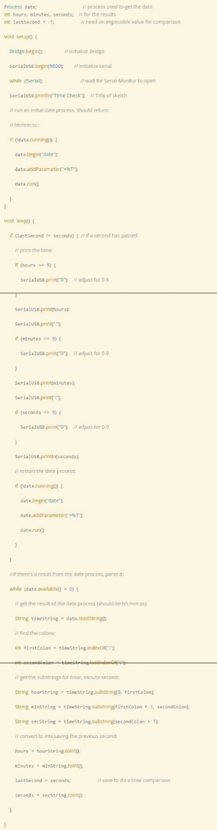

# Modified Code

We modified the code so that it would work with our LCD display.

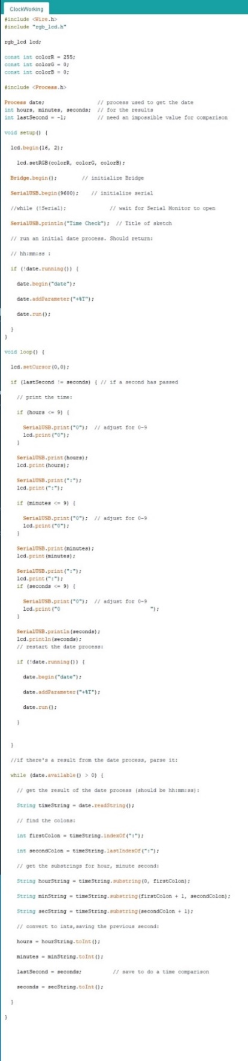

# Controlling the LED

We found this code online for controlling a LED with the light sensor in the grove kit. I modified it to work with two LEDs but unfortunately, I couldn’t get it to work with more than one LED.

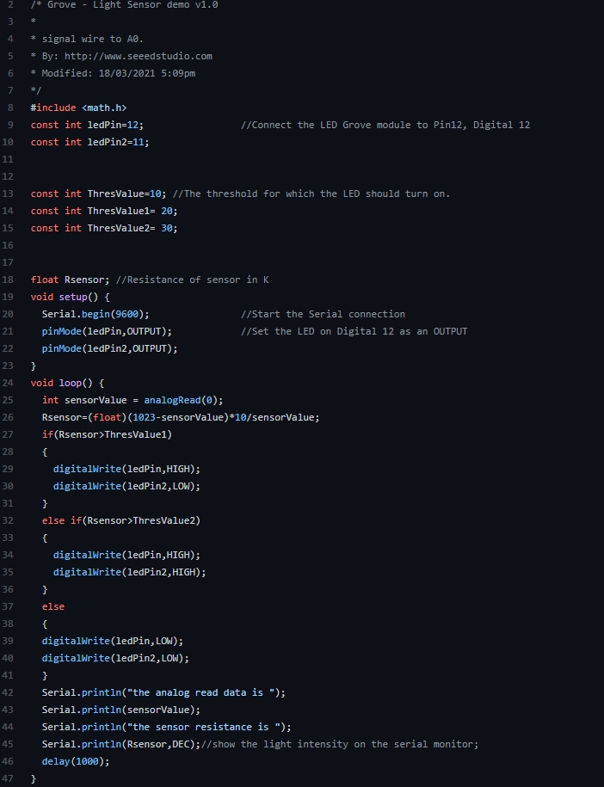

# Final Code

For the final code I just combined the time reading code and the LED code into one project.  
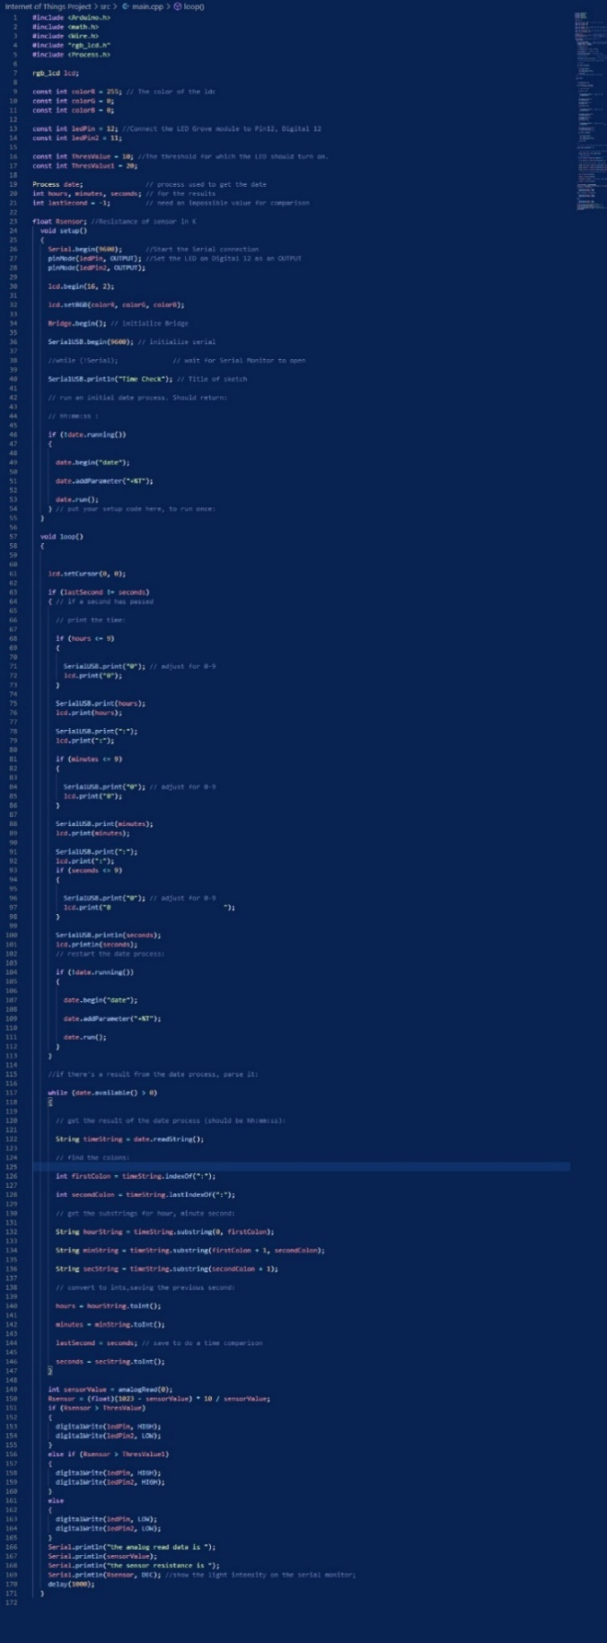

# Proposed hardware setup

The hardware we will use for this project are:

* Base shield
* LCD RGB Backlight
* LED x2
* Light Sensor
* Wires

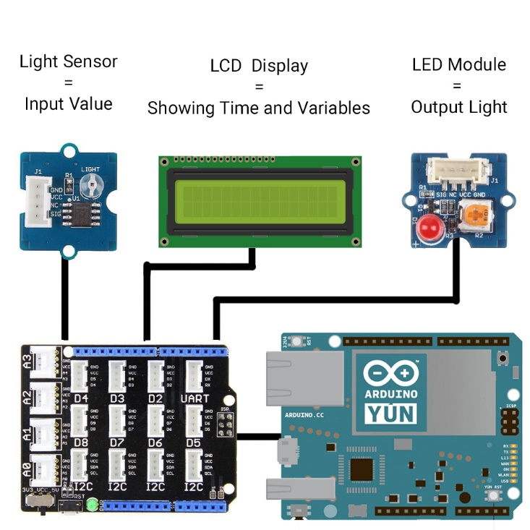

Implementation Plan

Our smart light is designed with the target audience of students and those who work from home. With this in mind we added a clock feature to make it more attractive to these audiences.

Most People have a clock and a lamp on their desk which takes up space, Without design we combine both of these with additional quality of life features.

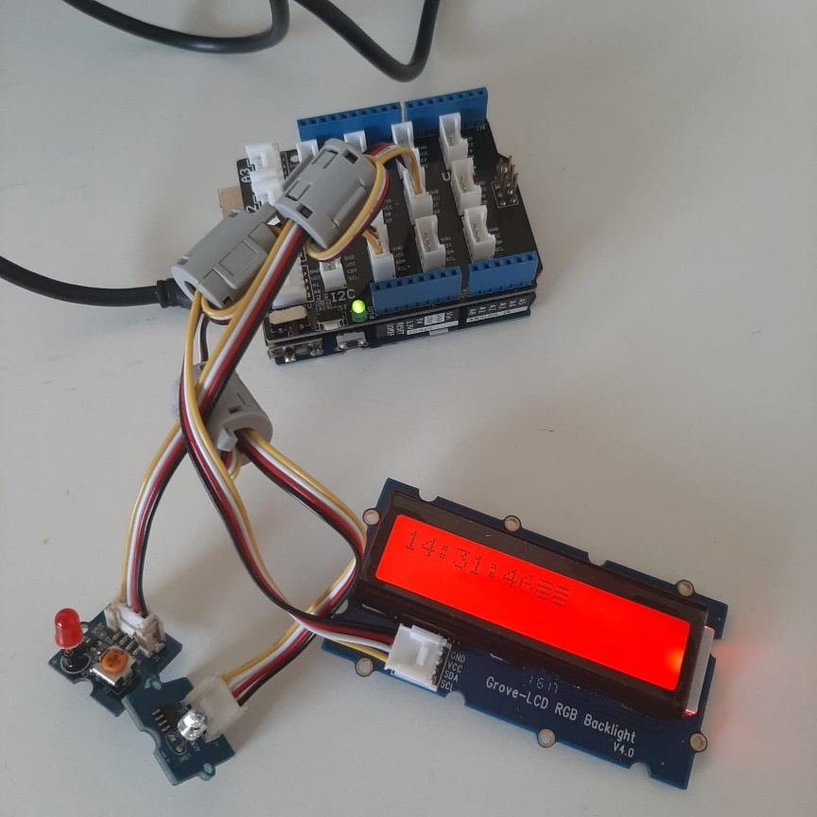

The great thing about our design is it does not require many parts to function

Parts List:

* Laptop / Desktop PC
* Arduino Yun
* Light Sensor
* LED Light
* LCD Screen

No additional equipment was needed other than the “Grove Kit”

Additionally, we do not use any APIs which helped keep the code smaller and more secure

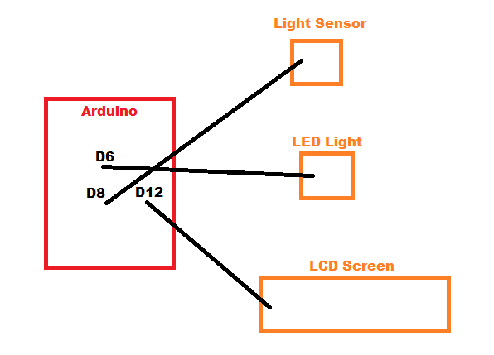

Code Samples

This section of code allows us to view what level of light the sensor is picking up, Allowing us to pick the correct level for the light to turn off and on at:

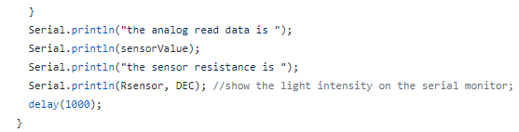

This section turns the LED of and on depending on the light levels:

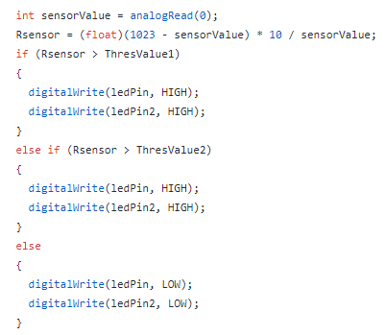

This is what tells the Arduino the time so it can display it on the LCD Screen:

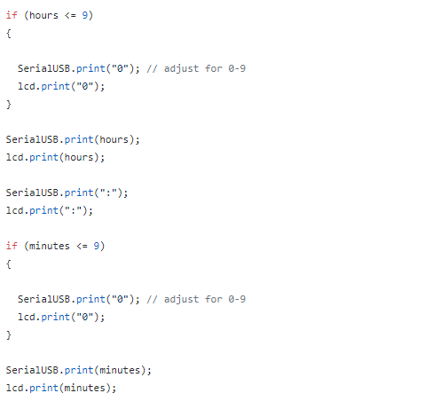

TESTING

Getting to testing took some time but we eventually got there, the first thing we decided to do was have a group meeting to decide on the best and most practical way for us to test a group. The group decided the best way to be fair would be to each to some of the code individually and later we could test it on the hardware as a group or individually. We would keep each other informed of any work done in the WhatsApp group we have and then updates would be posted to both the Trello and GitHub pages. The first test run we done was unsuccessful we used a breadboard several led lights, resistors and wires along with the Arduino Yun and grove kit. For the second test we decided to remove the breadboard and use the Arduino, grove kit, led socket and light sensor. This test went a little better the led worked and was responsive to the sensor, the led was in port 12 and the sensor was in A0 and there was no reading from the serial monitor. We decided we would like to make further improvements and add a clock to the project which required us to add some more code. This time our testing was not fully successful we got the clock working but the led light was constantly lit and unresponsive to the sensor. Back to the drawing board which required us to tweak the code slightly and once we tested it further it looked like we had it. We then noticed the clock would stop working once the led was plugged in. once again we made some small changes to the code changing the led IN to port six, leaving the clock in port twelve and the sensor in the A0 port. Success, the led was fully responsive to the sensor and the clock was reading in the correct time. When we opened the serial monitor, we could see the sensor was responsive to the different levels of light which it previously wasn’t which was what we had hoped to achieve. It took a little longer than expected to get there but it was a little expected at the same time, we kept chipping away at it as a team and got the desired result in the end.

**First attempt at testing with breadboard-unsuccessful**

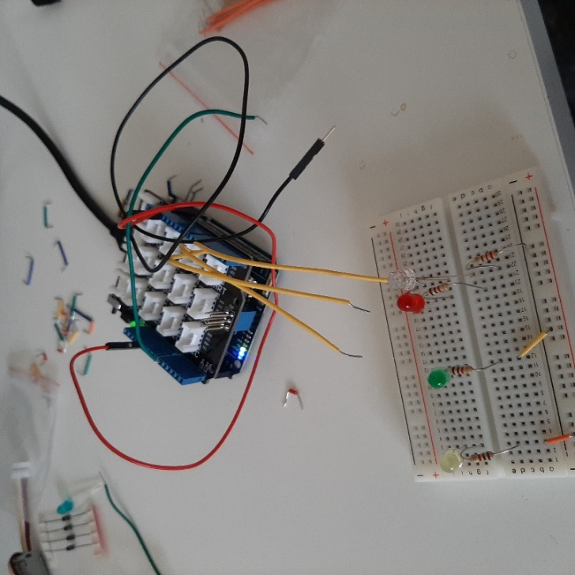

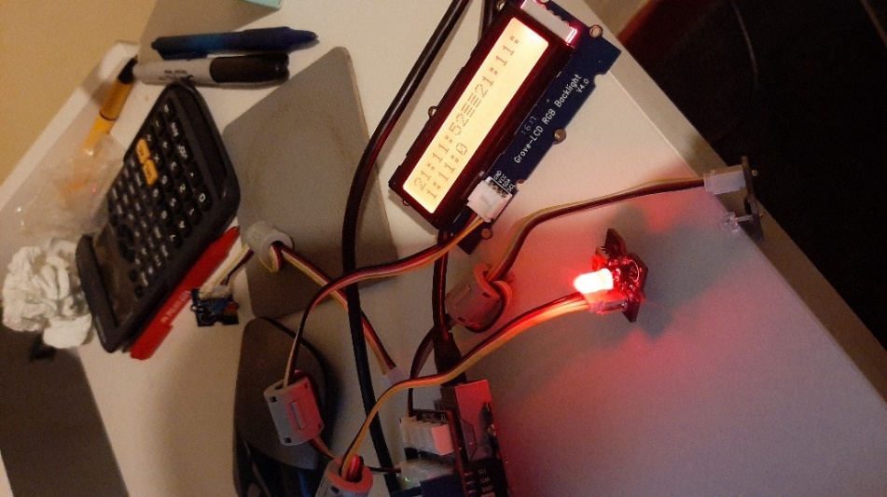

2nd test partial success clock works but prints more than once and led is lit constantly

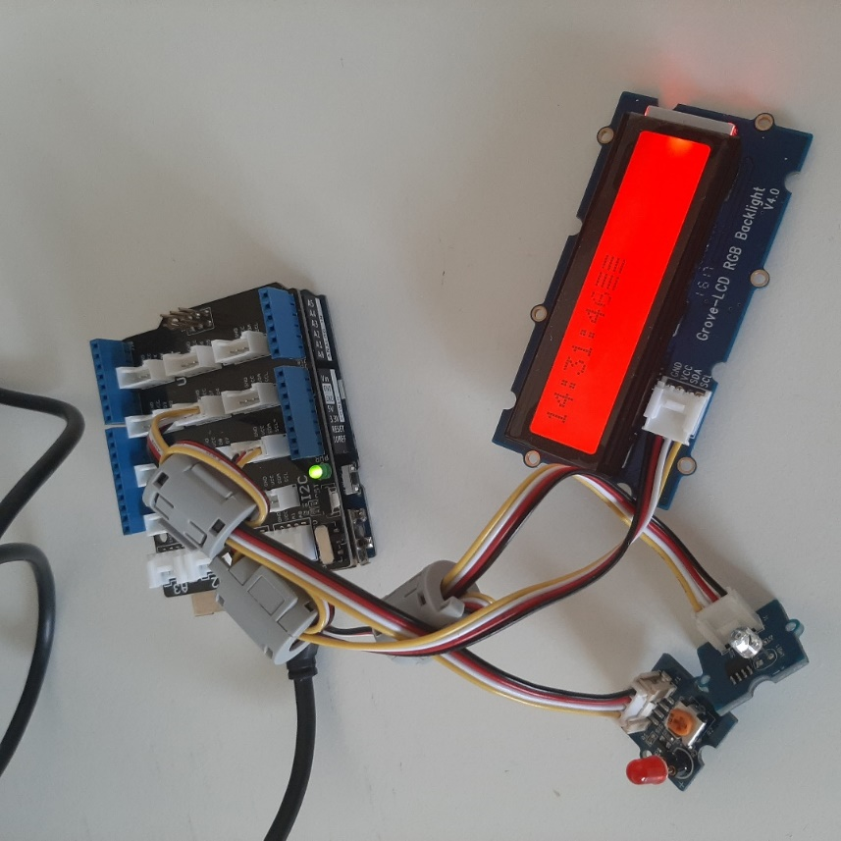

Final project clock working and responsive to light sensor.

Future  
  
For the future of our project we plan to implement several leds rather than just one because we believe it would be pretty cool to see several leds responding to the light sensor at once. This would also give us a better idea of what it would look like as an actual lamp. Another improvement we would like to implement is the use of a website interface which would allow us to control the project from a mobile phone. This could not only be used to turn the light on and off but also perhaps also record light readings or set a timer for the light, but this would all depend on further investigation of course. we would also like to add an indicator to let the lamp tell the person how long they have been sat in their workstation and when it is time to take a break. There are already some websites and applications to do this for smart bulbs so we believe this could be added to our project. For future possibilities this could be used in office lighting where people are working long hours so they do not have to worry the lasting effects the lighting could have on their eyes. Another area it would work would be in schools and colleges where students are also studying for long hours and laptops are becoming a bigger part of education each day. An area it could also be implemented is in the use of car headlights so the lighting would not have a damaging effect on the eyes of not just drivers on long journeys but also professional drivers such as lorry drivers or delivery drivers. The scope for ideas is large where it could be used in such areas as shopping centres, flashlights, phone and laptop screen lighting all which could benefit peoples eye health and mental health which studies have proven. As a group an area we would also like to investigate for the current project would be energy efficiency, to make our project perform the same task while using less energy to perform the same task. This would also benefit some of the future possibilities mentioned earlier as it could assist us in getting as low an energy as possible to make it environmentally friendly. We would also look at the possibility of adding some more sensors and another screen to the project which would read temperature and humidity of the workspace area. As we would like to have mobile phones controlling the light, we could also investigate perhaps adding a usb port to the project so the user could connect other devices such as phones or other smart devices. It would also be interesting to see if the project could be connected to a dimmer switch in the home which would allow the user to adjust the light manually as some may be more sensitive to different levels of light compared to others. There are so many possibilities and different areas we could explore with this project which would be the reason we would be happy to continue with it for project two. It is exciting for us as a group to be able to explore these new areas but it also gives a lot of satisfaction to not only see the project working but allow us to work with a physical device and kit when the most of our first year was online. We have our first IoT group project now complete and enjoyed it, with the easter break now upon us this gives us a chance for a much-needed break, some chocolate and some free time. We are hoping that with some of this free time it will give us a chance to investigate and research the planned implementations for project two and furthermore give us an opportunity to look for new ideas which we can add to the project. It also gives us something to look forward to which is another chance to work together and work with the Arduino Yun and grove kit which to our surprise is something so small yet so powerful. As we know with great power comes great responsibility.

1. (Hatori, M., Gronfier, C., Van Gelder, R.N. et al. Global rise of potential health hazards caused by blue light-induced circadian disruption in modern aging societies. npj Aging Mech Dis 3, 9 (2017). https://doi.org/10.1038/s41514-017-0010-2)
2. Tosini, Gianluca et al. “Effects of blue light on the circadian system and eye physiology.” Molecular vision vol. 22 61-72. 24 Jan. 2016
3. Yoshitaka Kaneita, Eise Yokoyama, Satoru Harano, Tetsuo Tamaki, Hiroyuki Suzuki, Takeshi Munezawa, Hiromi Nakajima, Takami Asai, Takashi Ohida,Associations between sleep disturbance and mental health status: A longitudinal study of Japanese junior high school students,Sleep Medicine,Volume 10, Issue 7,2009,Pages 780-786,ISSN 1389-9457,https://doi.org/10.1016/j.sleep.2008.06.014.